Proposed Possible Method for Optimizing the Routing Process from Maze Search Algorithm to A* Algorithm

The **Maze Search Algorithm** in PCB routing is used to find the optimal path between two points by expanding possible paths in a breadth-first manner. While this is effective in finding paths, it does not always prioritize the most optimal or shortest path early in the search, leading to increased search time and inefficient routing.

Shifting to an **A* (A-star) algorithm**, which is a heuristic-based pathfinding algorithm, can significantly improve the routing process. A* combines the benefits of both Dijkstra's algorithm (guaranteeing the shortest path) and Greedy Best-First Search (prioritizing paths that seem closer to the goal). A* uses a heuristic function to evaluate each potential path based on both the cost to reach the current point and an estimate of the cost to reach the goal.

**Key Improvements with A* Algorithm**

1. **Faster Pathfinding**: A* prioritizes paths that are more likely to lead to the goal, reducing the number of expansions needed and making the routing process faster.
2. **Better Path Quality**: The heuristic in A* (typically the Manhattan distance in grid-based systems) helps guide the algorithm toward more optimal paths, leading to fewer vias, shorter traces, and more efficient use of space on the PCB.
3. **Flexibility in Heuristics**: A* allows for more flexibility in selecting heuristics, which can be tailored to specific routing constraints (e.g., avoiding obstacles, trace length, vias, etc.).

**Steps for Shifting from Maze Search to A\***

**1. Understanding the Differences Between Maze Search and A* Algorithm**

The **Maze Search Algorithm** expands equally in all directions from the starting point, often exploring areas that are far from the destination. This leads to an exhaustive search which can be slow and inefficient.

The **A* Algorithm** improves upon this by introducing a heuristic:

* **Cost (g)**: This represents the exact cost from the start point to the current point.
* **Heuristic (h)**: This represents the estimated cost from the current point to the destination (e.g., Manhattan or Euclidean distance).
* **Evaluation Function (f)**: This is the sum of the cost and heuristic: f(n)=g(n)+h(n)f(n) = g(n) + h(n)f(n)=g(n)+h(n) The algorithm expands the node with the lowest f(n) value, which prioritizes nodes closer to the goal and likely to lead to the shortest path.

**Possible Efficient Memory Management Issues**

A* algorithms can consume significant memory when managing large grids. You need to ensure efficient memory management, such as using lazy evaluation or limiting the number of open nodes.

**Testing the A Algorithm**

Once implemented, rigorous testing is required to ensure the A* algorithm performs well in the context of PCB routing. Some areas to focus on:

* **Performance**: Ensure the A* algorithm finds paths faster than the maze search.
* **Path Quality**: Ensure the algorithm produces high-quality paths with minimal vias and short traces.
* **Heuristic Tuning**: Test different heuristics (e.g., Manhattan vs. Euclidean) to find the best fit for your routing scenarios.
* **Memory Usage**: Monitor memory consumption, especially on complex boards with many open nodes.

**Conclusion**

Switching from a **Maze Search Algorithm** to the **A* Algorithm** will significantly improve the efficiency and quality of the PCB routing process. A* reduces the number of nodes expanded, prioritizes optimal paths, and handles PCB-specific constraints like obstacles, vias, and layer switches more effectively. With the outlined steps and adjustments, your routing process can become faster and more reliable.

# Possible methods improving rendering process:

Improving routing and rendering performance is crucial for large-scale PCB designs where computational and graphical efficiency can directly affect user experience and overall productivity. Batch optimization, where you render or route only the parts that change, is one effective method.

In addition to this, there are various other approaches we can propose to optimize both routing and rendering. Below is a detailed explanation of how to achieve this, along with other suggestions for improving performance.

**1. Batch Rendering for Dynamic Updates**

Rendering a PCB can be highly computationally expensive when the entire board is redrawn every time a small part of it changes. A more efficient method is **batch rendering**, where only parts of the design that change are updated, leaving unchanged areas as they are.

**How Batch Rendering Can Be Applied:**

* **Track Modifications**: Use a dirty rectangle system to track areas that have been changed in the design (e.g., modified traces, newly added vias, or rerouted connections).
* **Partial Redrawing**: Instead of redrawing the entire board, update only the parts that have been modified. By tracking the "dirty" areas (i.e., the regions that need updating), you can limit the redraw process to a subset of the board.
* **Buffering Static Elements**: You can pre-render sections of the board that are unlikely to change and store them in buffers. When rerouting happens, these static sections don't need to be redrawn, and you can reuse the pre-rendered buffers. For instance, areas that contain fixed components, static traces, and power planes can be stored and reused.

**Potential Impact:**

* **Faster Rendering**: This approach reduces the computational load by preventing unnecessary redraws of the entire board, focusing resources on only what is changing.
* **Lower Memory Usage**: By rendering in smaller batches and keeping unchanged areas cached, memory usage remains optimized, leading to faster access and rendering speeds.

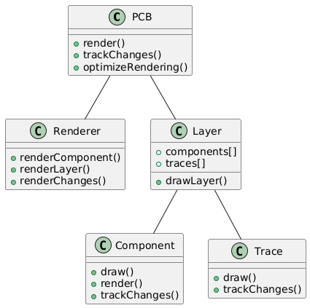

**2. Incremental Routing for Batch Optimization**

In large PCB designs, rerouting entire sections can be inefficient, especially when changes are isolated. Incremental routing aims to limit routing changes to only affected sections.

**Incremental Routing Process:**

* **Track Localized Changes**: Instead of re-routing the entire PCB, monitor and reroute only the parts of the design that have changed, like a specific trace or net that has been modified.
* **Connection-Based Updates**: If only certain connections are rerouted, batch reroute only those connections and leave the others unchanged. For example, if a trace between two components is updated, reroute only the trace for that net, and avoid recalculating the entire network of traces.
* **Deferred Optimization**: Rather than constantly re-optimizing the entire board after every small change, apply routing changes in small batches, and run a global optimization pass only when necessary (e.g., at major milestones).

**Potential Impact:**

* **Reduced Computation**: By rerouting only localized sections, the overall routing process becomes faster and more efficient, with fewer resources wasted on unchanged areas.
* **On-the-Fly Adaptation**: Changes can be made in real-time without the need for long delays while the entire board is recalculated.

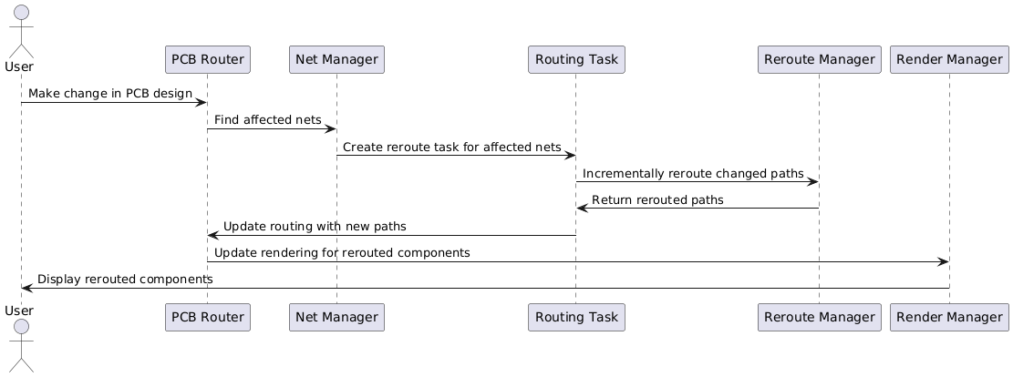

**3. Multi-threaded Rendering and Routing**

PCB routing and rendering can benefit significantly from multi-threading, especially on modern processors. By leveraging multiple CPU cores, tasks like rendering, routing, and optimization can run in parallel, greatly improving performance.

**How Multi-threading Can Improve Performance:**

* **Parallel Routing**: Divide the board into different regions and route each region independently in parallel. Each thread can handle a subset of the routing tasks, such as working on different nets or different layers simultaneously.
* **Parallel Rendering**: Layers or components can be rendered in parallel. Each thread can handle the rendering of a specific layer (e.g., component layer, trace layer, via layer) independently.
* **Task Queuing**: Use a thread pool to manage tasks that require recalculating or rerouting and allocate tasks dynamically. This allows better load balancing and more efficient use of CPU resources.

**Potential Impact:**

* **Improved Utilization of Resources**: Multi-threading ensures that all available CPU cores are used, reducing idle time and speeding up both routing and rendering processes.
* **Scalability**: As more CPU cores are added, the performance will continue to improve, making the system more scalable for large designs.

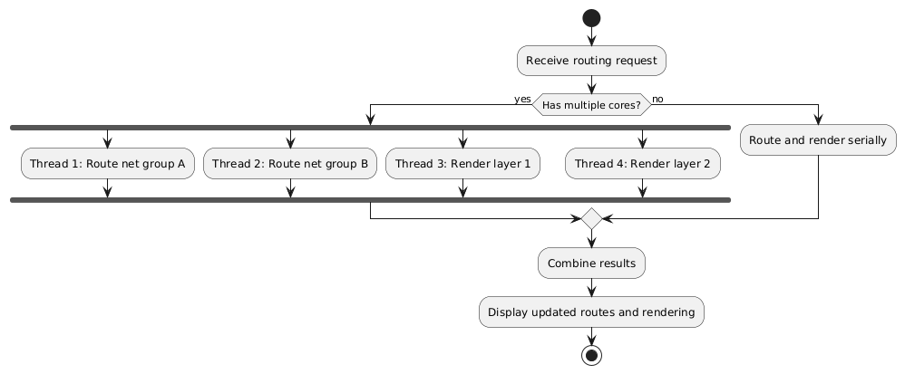

**4. GPU-Based Rendering**

Modern GPUs (Graphics Processing Units) are optimized for parallel processing of graphical tasks. By offloading rendering tasks to the GPU, we can significantly improve rendering speed, especially for complex designs.

**How GPU-Based Rendering Works:**

* **Offloading to GPU**: Offload rendering tasks, such as drawing traces, vias, and components, to the GPU. This frees up the CPU for routing and optimization tasks while the GPU handles rendering.
* **Hardware Acceleration**: Use hardware-accelerated rendering techniques, such as OpenGL, Vulkan, or DirectX, to leverage the full power of the GPU for drawing the PCB layout in real-time.
* **Shader-Based Optimizations**: Implement shaders to handle complex visual effects, like anti-aliasing or zoom, without affecting performance.

**Potential Impact:**

* **Drastically Faster Rendering**: GPUs are optimized for high throughput rendering tasks, and they can handle thousands of elements (traces, vias, components) in parallel, significantly speeding up the rendering process.
* **More Responsive UI**: Offloading rendering to the GPU ensures that the UI remains responsive even when dealing with large designs.

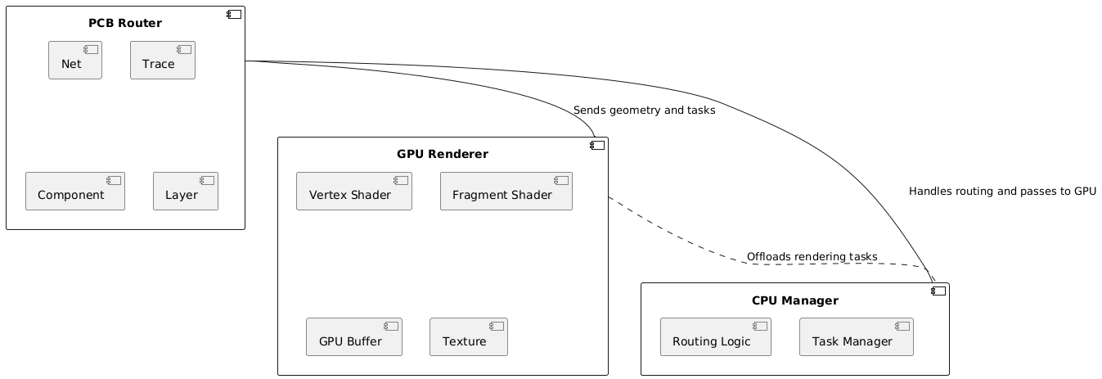

**Conclusion**

To summarize, here are the proposed methods for improving routing and rendering performance using batch optimization:

1. **Batch Rendering for Dynamic Updates**: Only update and redraw parts of the PCB that have changed, reducing unnecessary rendering of static parts.
2. **Incremental Routing**: Reroute only the parts that change, rather than reprocessing the entire board.
3. **Multi-threaded Rendering and Routing**: Use parallelism to speed up both routing and rendering processes.
4. **GPU-Based Rendering**: Offload graphical rendering tasks to the GPU for faster processing.